# SUNDAY LAWN IMPLEMENTATION

Natalia Sanchez Castillo

**Executive Summary:**

Sunday lawn is a game developed in summer in a small town in Italy. Since it is summer, the grass on the houses in this neighbourhood has not stopped growing. The main character, Pablo, aims to keep his neighbours' grass short with the highest number of points. This is a top-down, side-scroller and single-player game.

In the game, Pablo will have to face different scenarios. Houses with extensive gardens and in them various enemies which you must avoid in order not to hurt yourself or damage your lawn tractor. The enemies that Pablo can find are dogs or porcupines. The game has different levels; To play the following levels, the player must unlock them. To do this, you must complete the previous levels successfully.

**Game Description:**

**Overview:**

Sunday lawn is a casual game. The game is located in a small town in Italy. The aesthetics of the game is typo pixel art. The days are sunny, and the houses are colourful. In the game, the player will have to cut all the grass of the assigned home. The user will earn points for every square meter cut.

The main character of the game is Pablo. Pablo is a young adult who wants to earn extra money in the summer. For this reason, he mows the grass in his neighbourhood. In the video game, we find two enemies that Pablo will have to face. The first is the dogs that guard the house. They can leave traps (poop) that the player must avoid. The second enemy is the porcupines which can injure the player.

**The Quest:**

The game's ultimate goal is to keep the main character's neighbourhood spotless. For this, the player must go through each house and mow the grass. The player will find a different house or map at each level, meaning the obstacles will differ. Each map is made up of stones, trees, fences and/or pools.

The player will receive stars at each level depending on his performance (the score the user obtains). The more square meters of grass cut, the more points you will get. When completing each level and receiving points for performance, the player will also receive stars depending on the score obtained. Each level will be unlocked when the player completes the previous level.

**Main Character:**

The main character of the game is Pablo. He is a young adult who wants to earn a few more dollars in his summer spare time. Pablo wears a casual blue shirt with red pants and brown shoes. The game is in the third person, and the screen moves up and down and side to side.

**Sketch of Main Character:**

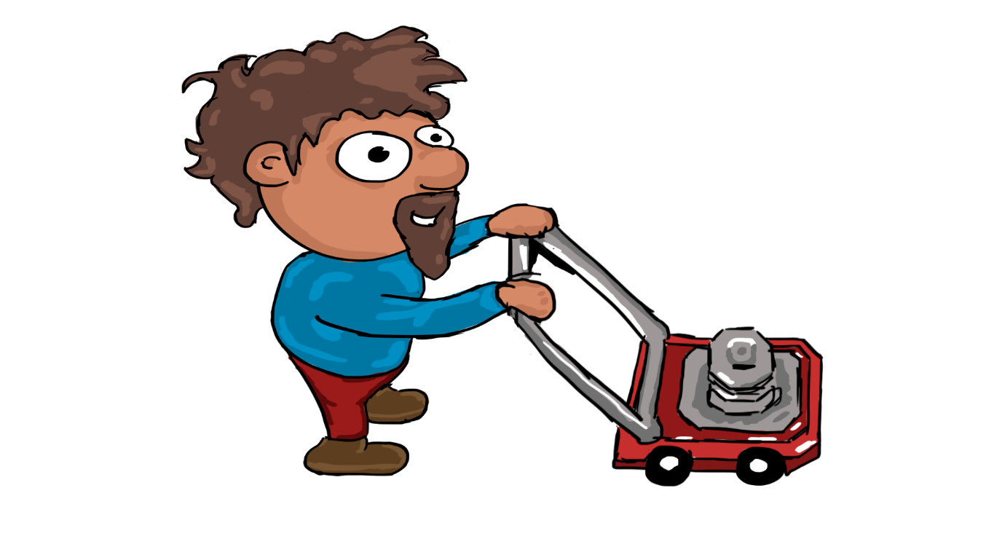

**Opponents:**

The game contains two primary opponents—the porcupines and dogs. Porcupines roam an area of the map and have a medium speed. If there is a collision between the player and the porcupine, the porcupine will damage the main character's machine.

The second opponent is the dogs. These opponents also hang around the house but have a faster speed than porcupines. If the player collides with the dog-type opponent, his lawn tractor will be damaged, and he will have to start the level over. Likewise, the dogs will leave obstacles (feces) which will subtract points from the player if they are stung.

Opponents will be assigned an area of the map and only move through that sector.

**Sketch of Opponents:**

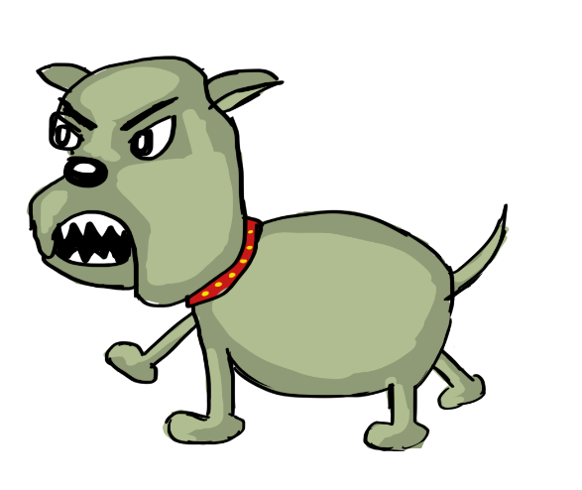 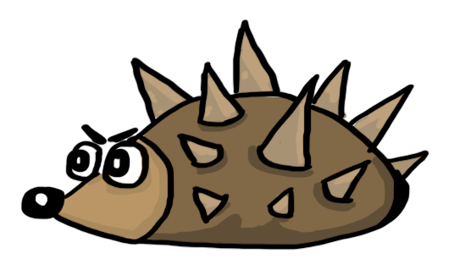

**Environment:**

The game is set in a suburb or suburban area. It has houses and large gardens. Some of the homes have swimming pools. Likewise, there are flowers, shrubs and trees and rocks. The houses have a country house-type look.

**Sketch of the World:**

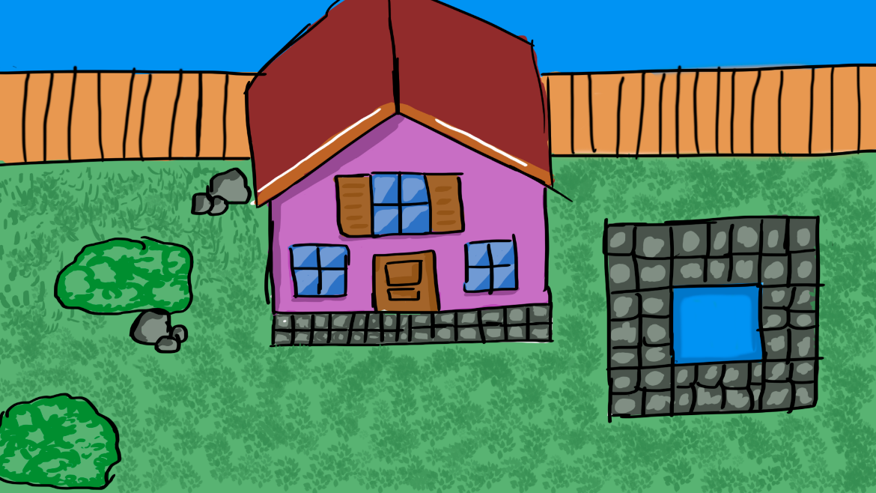

**Menus:**



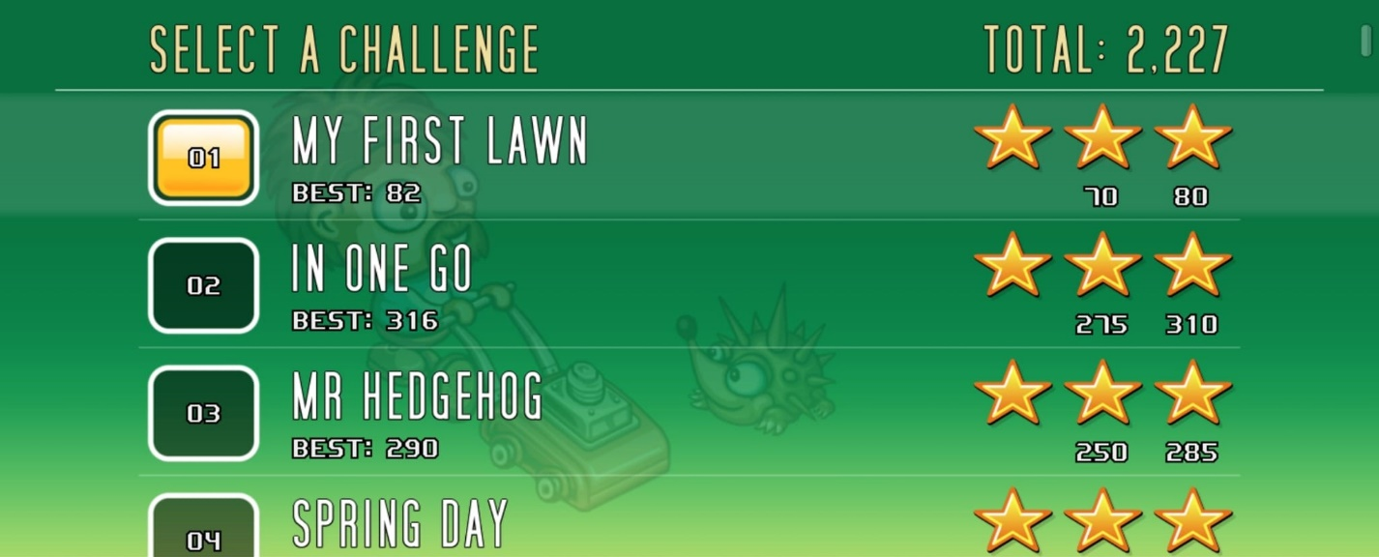

**Controls:**

The main character will be controlled with the up, down, left and right arrows. Likewise, it can be moved with the keys W (up), A (left), S (down), and D (right). The enter key will be used to select within the menus. The P key will pause the game, and the Q will exit the level.

**Sounds:**

The game will have upbeat music, giving it a summer feeling. It will have background sounds like birds singing, the sounds of the player's footsteps, and the tractor engine. On the other hand, they open sounds when the player collides with the enemies and when the user completes the level.

**Summary:**

It's summer, and the grass in this suburb doesn't stop growing. A young adult, Pablo wants to help his neighbours earn a few extra dollars. For this reason, he decides to mow the grass in his neighbourhood in his spare time. Pablo will face different levels. The difficulty will increase as you level up. Each level will be unlocked when the player completes the previous level. On each map, he will find enemies, which will make the task of mowing the lawn more difficult. The player must avoid these opponents and cut all the grass to complete the level.

The player will get a score and, with it, several stars.